Week 11 Report

CNN

37237256 薛丁銘

The code of this week is as shown in Figure 1.I tried to add 4 convolutional layers to the network but it showed error messages. I think the limit should be 3 because the network has to maintain its shape after pooling. The accuracy increased with epochs. The results are as shown in Figure 2.

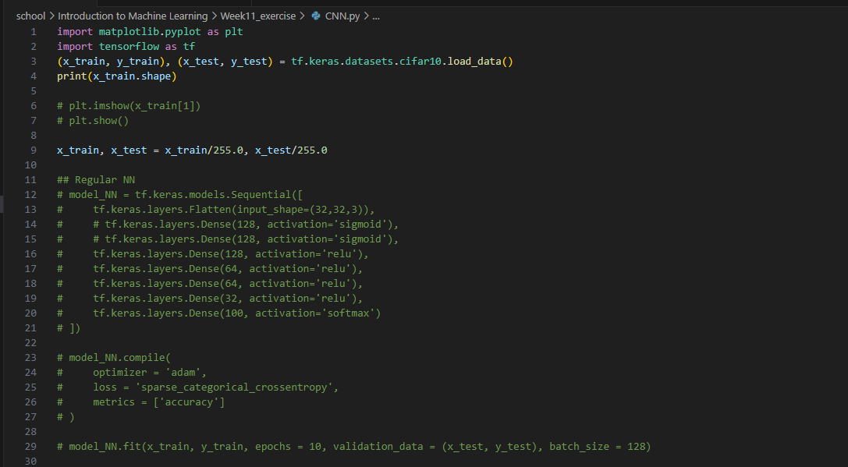

Figure 1.a Code

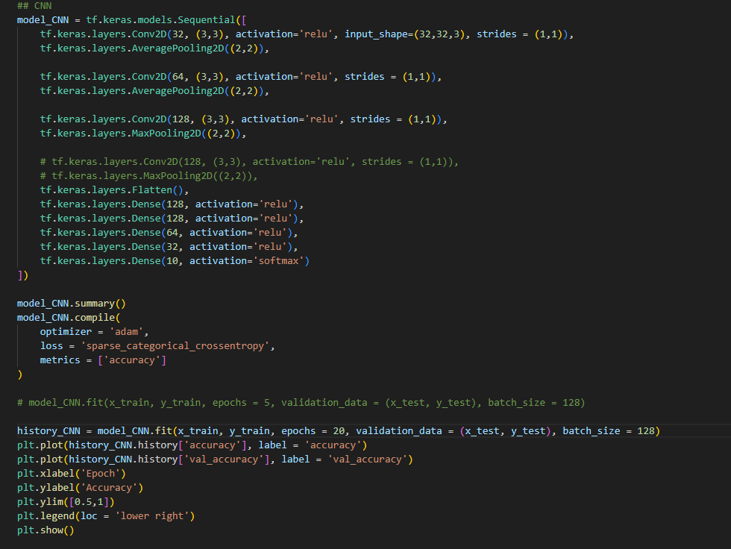

Figure 1.b Code

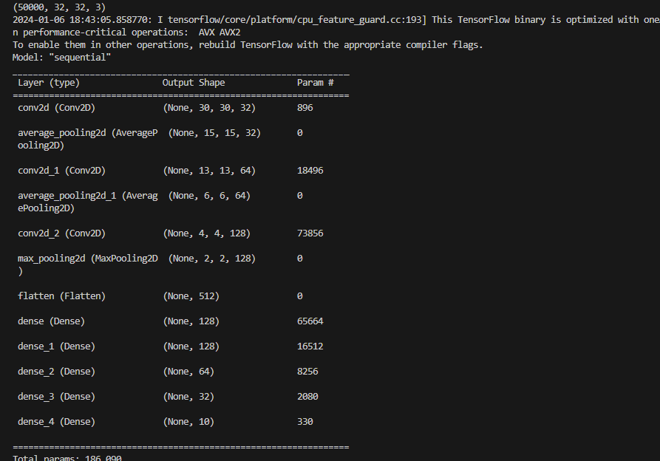

Figure 2.a Results

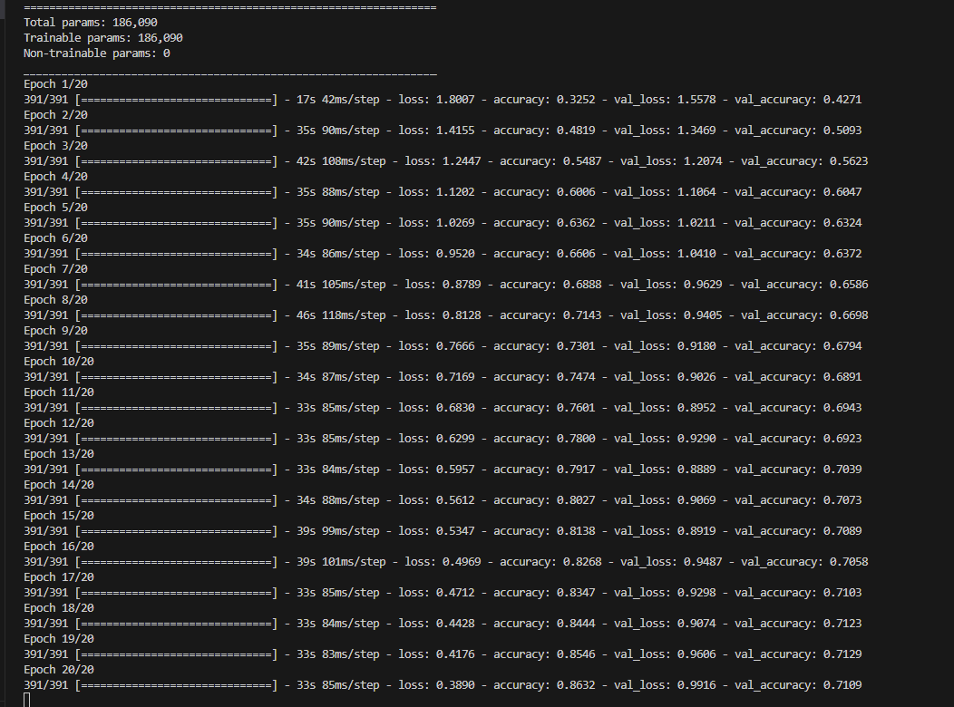

Figure 2.b Results

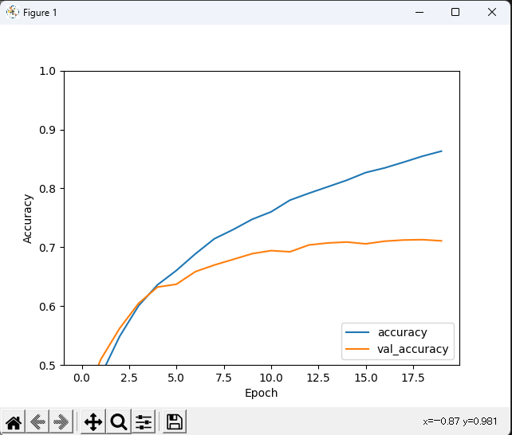

Figure 2.c Results